Report on International Customs Day 2018

International Customs Day 2018 (26 January)was observed in Bangladesh with great fanfare as elsewhere around the world. In this regard, National Board of Revenue (NBR) undertooka wide range of programmes to celebrate the day in a befitting manner.The day was observed centrally in the capital by the NBR and was also observed locally at each office of Bangladesh Customs.

A special supplement was published in 11 popular and widely circulated daily newspapers in Bangladesh on this occasion. Hon’ble President of Bangladesh H.E. Abdul Hamid and Hon’ble Prime Minister H.E. Sheikh Hasina both issued separate messages on this occasion. In their messages, they felicitatedall officials of Bangladesh Customs, the taxpayers and the relevant stakeholders for their constructive roles in the development of the country. They further praised WCOfor choosing a time-befitting theme for the Day, a.i., ‘A secure business environment for economic development’.

The government unveiled a commemorative postage stamp and afirst day cover (FDC) on the occasion. NBR brought out a colourful rallyin the morning to mark the day. Besides, NBR made a documentary on the activities and achievements of Bangladesh Customs to raise awareness among the general people.

As part of the day’s programme, NBR organized a seminar at the Pan Pacific Sonargaon hotel in the evening. Hon’ble Finance Minister H.E. Mr. AbulMaal Abdul Muhit, MP;Hon’ble Commerce Minister H.E. Mr. Tofail Ahmed, MP and Economic Affairs Adviser to the Hon’blePrime Minister H.E. Dr.Mashiur Rahman participated at the seminar. Officers from Bangladesh Customs; senior officials from Ministry of Finance and other ministries; representatives from private entities and relevant stakeholdersattended the seminar.During the seminar, NBR honoured 14 officials from Bangladesh Customs and 6 stakeholders (individuals and organizations) with WCO Certificate of Merit for theirvaluable contribution to the activities of Bangladesh Customs.

On the eve of ICD 2018, Chairman of the NBR Mr. Md. Mosharraf Hossain Bhuiyan, ndcbriefed the press about the event. During the briefing, he highlighted the theme adopted for the occasion and said that NBR would remain true to its commitment and would do the utmost for ensuring a business-friendly environment and thus would contribute towards the development of the economy.

Pictures: Celebration of International Customs Day in Bangladesh

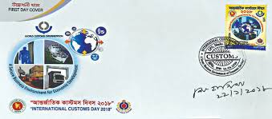
First Day Cover (FDC)

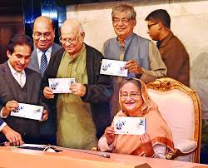
Unveiling of FDC by Honourable Prime Minister

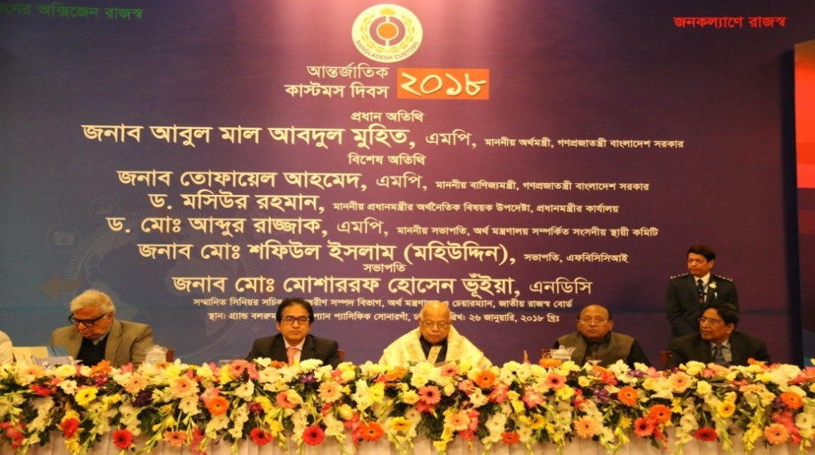
Seminar on International Customs Day 2018, presided over by Chairman, NBR;
Hon’ble Finance Minister (in the middle) was the Chief guest;
Hon’ble Commerce Ministerwas the Special guest;

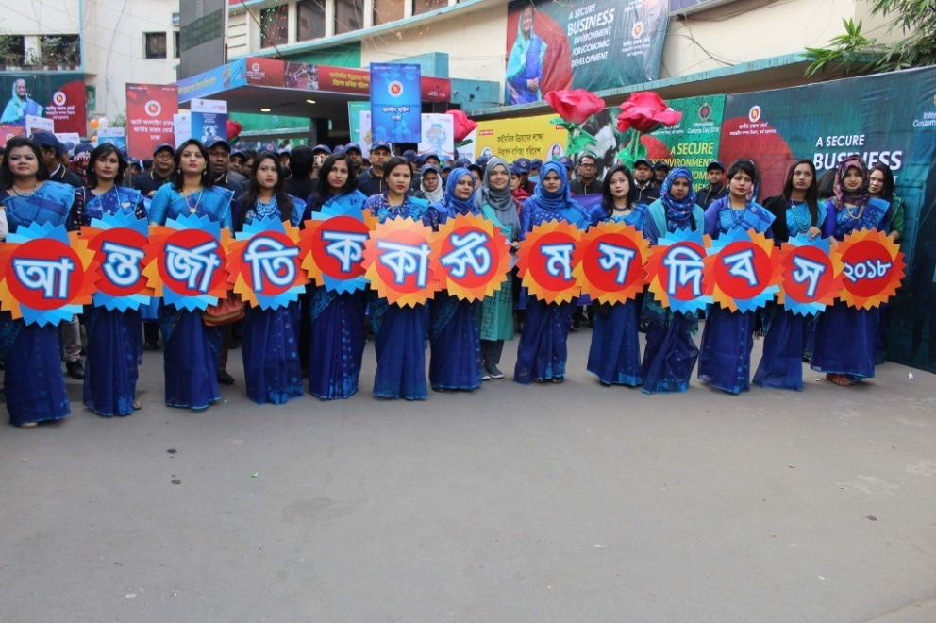
Rally: Lady officers from Bangladesh Customs

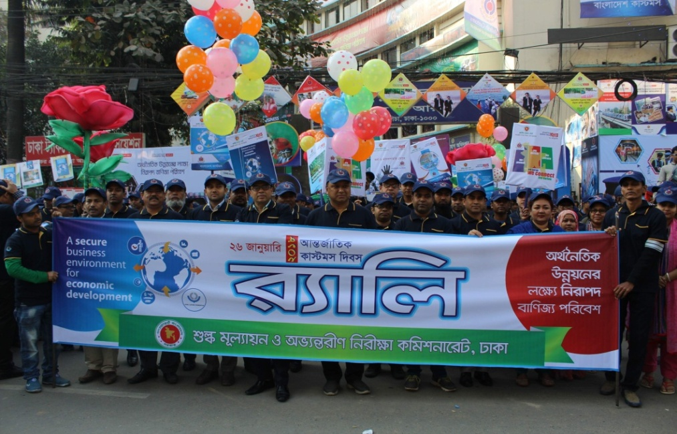
Officials at the Rally

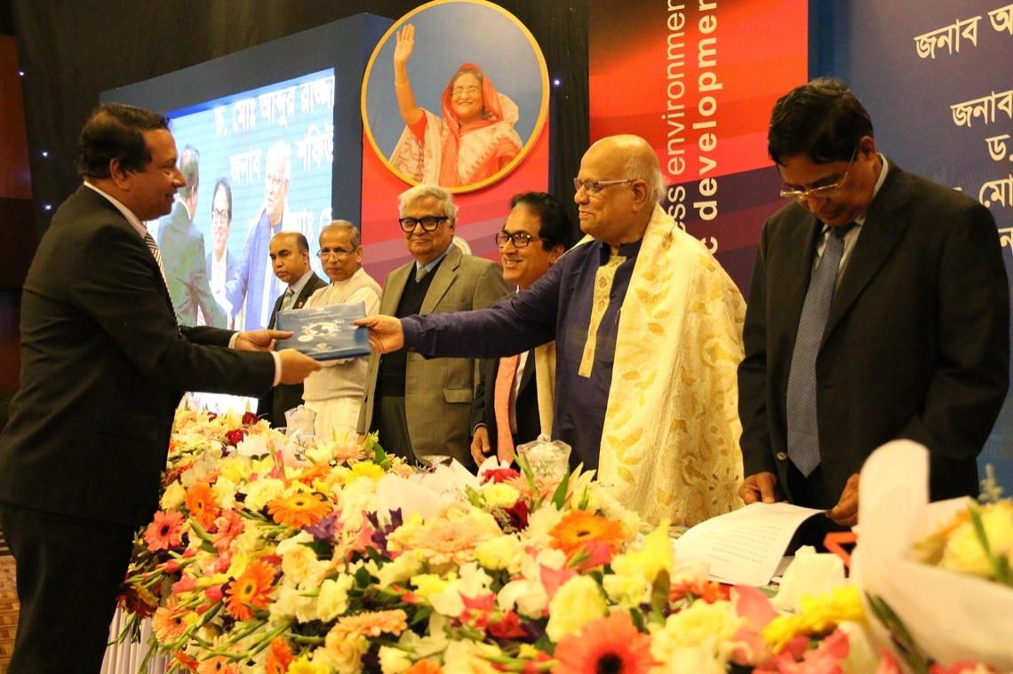

Ministry of Commerce (MoC), a very important stakeholderwasawarded with the WCO Certificate of Merit. The Secretary to the MoC is receivingthe Certificatefrom HFM.

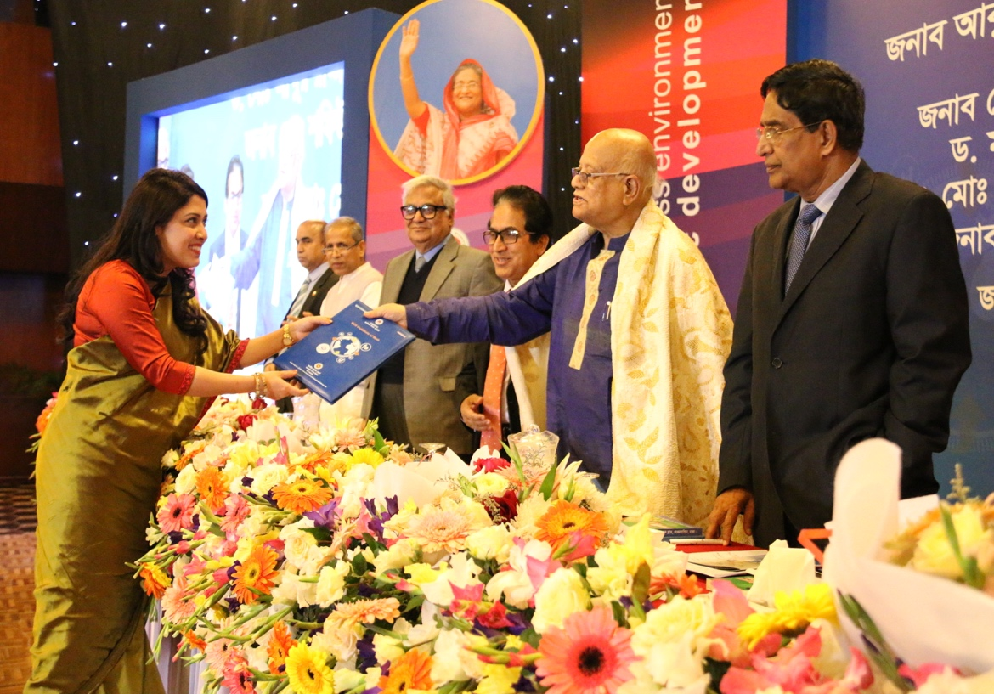
Officer from Bangladesh Customs is receiving WCO Certificate from HFM

Necessary Links:

Link to the special supplement on ICD 2018:
http://epaper.thedailystar.net/index.php?opt=view&page=17&date=2018-01-26

Link to the documentary on Bangladesh Customs:
https://www.youtube.com/watch?v=_jmEZGJf7Oo

