Guidelines concerning the RSC/61 Session

Guidelines for participants on the conduct of the RSC/61 through the CLiKC! and Zoom platforms

Table of Contents

I. HOW TO REGISTER FOR THE RSC MEETING 2
Registration to the meeting 2
Registration to the WCO CLIKC! platform 2
Enrolment into the CLiKC! RSC 61st Forum group 3
II. AGENDA FOR THE RSC/61 3
III. PARTICIPATION IN THE DOCUMENT-BASED (CLiKC!) FORUM 3
Accessing the forum 3
File Repository 4
Discussion Forum for the RSC/61 4
Opening of the meeting 5
Launch of discussion topics 5
Providing comments on Agenda items and potentially concluding 5
Consensus 6
Virtual Meeting Room 6
Chatroom 7
IV. PARTICIPATION IN THE WEB-CONFERENCE (ZOOM) SESSIONS 7
Zoom platform for web-conference sessions 7
Opening a Zoom session 7
Participating in a Zoom session 8
V. REPORTING 8

HOW TO REGISTER FOR THE RSC MEETING
In order to take part in the meeting, the Member delegates will need to:
- register both for the RSC meeting as usual on the WCO’s website; and
- if they do not already have a CLiKC! Account, register on the WCO CLiKC! platform.
After this, the Secretariat will enrol them into the CLiKC! RSC/61 Forum group.
The Observer delegates will be directly enrolled into the CLiKC! RSC/61 Forum group after having registered for the meeting.
Details of the process are indicated below.

Registration to the meeting
Each Member is invited to nominate one or more delegates to participate. A Delegation needs to have one person registered as the Head of Delegation, with any additional Delegation Members registered as either Alternates or Advisors.
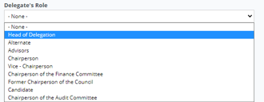

All delegates, including the Chairperson and Vice-Chairpersons, must register for the RSC meeting separately in the usual online manner through the WCO Members’ website.
Important Note: As this list is also used for enrolling participants in the CLiKC! forum, it is essential that each Delegate has their own email address.
Organisations with Observer status also need to register their delegates in the same fashion, but if they do not have access to the WCO Members’ website, they can register their delegates by sending the request to: hs@wcoomd.org.
Registration for the RSC/61 must take place by 3rd November 2022 (24:00), at the latest. This ensures that all necessary registrations and set-up of accounts can be completed.
Please ensure to register before these dates to have access to the Forum from the beginning of the meeting.

Registration to the WCO CLIKC! platform
Each delegate must register, or be registered, on the WCO CLiKC! platform.
Member delegates who are new users of the CLiKC! platform, will need to register by submitting an online request at the following link: https://clikc.wcoomd.org/login/signup.php.
They will be registered by their CLiKC! National Coordinator.
The list of all CLiKC! National Coordinators, who may be contacted by the delegates directly, is available at the following link: https://clikc.wcoomd.org/totara/reportbuilder/report.php?id=110.
For any issues related to the National Coordinators (if there is not a designated National Coordinator, etc.), delegates should contact the CLiKC! Team at elearning@wcoomd.org with a c.c. to hs@wcoomd.org.
For any issues regarding access to the CLiKC! platform, delegates may contact the CLiKC! Team at elearning@wcoomd.org with a c.c. to hs@wcoomd.org.
Representatives from Observer organizations can be registered by the CLiKC! Team by sending the contact details (title, name, position and email address) for each delegate to: elearning@wcoomd.org with a c.c. to hs@wcoomd.org.
The RSC Chairperson and Vice-Chairpersons need to be registered on the CLiKC! platform along with all other delegates.

Enrolment into the CLiKC! RSC/61 Forum group
The Secretariat will enrol Member delegates into the CLiKC! RSC/61 Forum group once they are:
- registered for the relevant meeting in the usual online manner through the WCO Members’ web site; and
- registered to the CLiKC! platform.
The enrolment will be done by the Secretariat, based on the list of participants registered for the meeting. Hence it is vital that the meeting registration is done correctly and that each Delegate has a separate email address.
To ensure consistency during the enrolment process, delegates wishing to register for the RSC meeting are asked to use the same e-mail address when registering on the WCO website and the WCO CLiKC! platform.
Observer delegates will be enrolled by the Secretariat directly into the CLiKC! RSC/61 group, once they have registered for the meeting.

Agenda for the RSC/61
The draft Agenda (Doc. NR1526) for the RSC/61 contains the questions to be examined by the RSC at its 61st Session.
The Agenda items will be examined both during the Zoom sessions and within the CLiKC! Discussion Forum, according to the distribution of items in the draft Timetable (Doc. NR1527). The RSC will decide if other items require a document-based review within the CLiKC! Discussion Forum.
The schedules for the Zoom and CLiKC! discussions are indicated in the draft Timetable (Doc. NR1527).

PARTICIPATION IN THE DOCUMENT-BASED (CLiKC!) FORUM

Accessing the forum
The document-based forum will take place through the CLiKC! meeting platform.
In order to have access to the CLiKC! meeting platform, delegates must first log into the CLiKC! platform using their personal username and password, through the link on the WCO website’s homepage or through the link https://clikc.wcoomd.org/

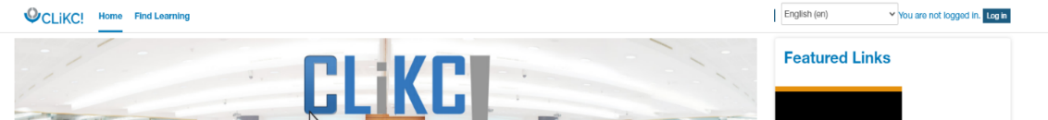
The link to log-in can be found at the top right corner of the opening screen.

Use of one of the following web browsers is recommended for best access to CLiKC!: Google Chrome, Mozilla Firefox, or Safari.
In the CLiKC! platform under ‘Home’ menu, specific Forum for the RSC/61 meeting will be created in the featured links.
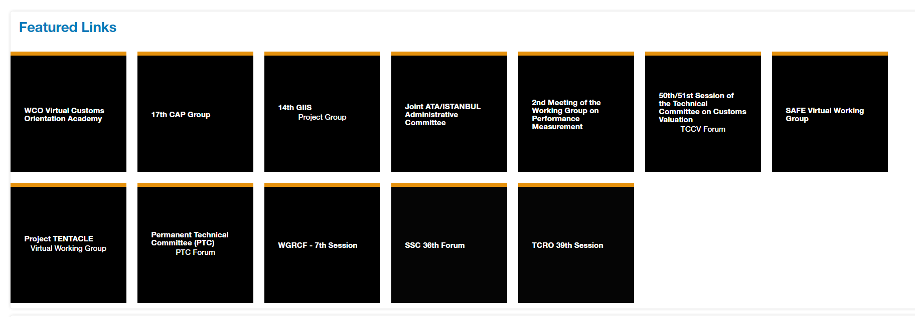

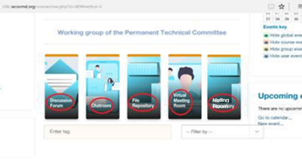
When delegates have access to the CLiKC! RSC/61 Forum group, they will be able to see the parts of the meeting platform - Discussion Forum, Chatroom, File Repository and Virtual Meeting Room.
The delegates will be primarily using the “Discussion Forum” and “File Repository” during the 61st RSC Session.

File Repository
All meting documents of the RSC/61 will be available in the File Repository by 7th November 2022, for the individual Agenda items, in both English and French languages
Documents will also be published on the RSC 61st Session page of the Members’ WCO website by 21 October 2022.
Files are organized by Agenda item.

Discussion Forum for the RSC/61
The document-based forum for the RSC/61 will be conducted mainly through the Discussion Forum. Delegates are invited to provide their comments, inputs and remarks, under the relevant discussion topics.
The schedules for forum discussions are indicated in the draft Timetable (Doc. NR1527).
When the forum discussions for each set of items is opened, delegates will receive an email in English and French, notifying them that the Topics for the relevant Items have been initiated within the “Discussion Forum” of the CLiKC! RSC/61 Forum group. All delegates can discuss the items and discussions will be visible to all delegates.
Times between the document-based forums (CLiKC! Forums) and the web-conference sessions (Zoom sessions) will be used to consolidate the inputs provided from delegates, allowing the Chairperson to prepare for the web conference.
Therefore, delegates are strongly encouraged to use the CLiKC! Forums to flag any comments, concerns and remarks, in order to facilitate the decision-making process during the web-conference sessions.

Opening of the meeting
At the beginning of the document-based forum of the meeting, the Chairperson will open it with a welcome and opening remarks and a welcome will also be given by the Secretariat. Any additional information for participants that may be relevant will also be given as required.

Launch of discussion topics
At the beginning of the document-based forum, “Discussion Topics” will be initiated for Agenda items as scheduled in the timetable.
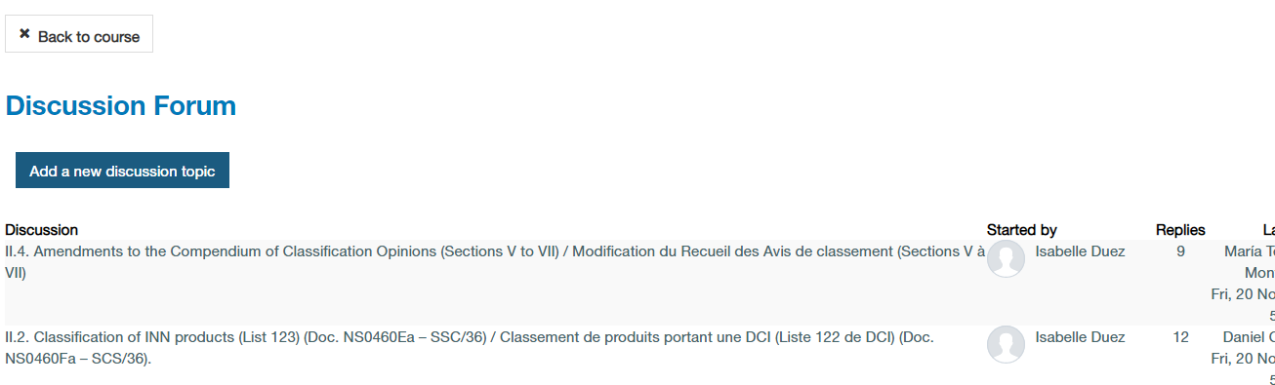

Delegates will receive an email in English and French, notifying them that a “Discussion Topic” has been initiated within the “Discussion Forum” of the CLiKC! meeting group.
Important: If for any reason a Delegate does not receive the opening email, they will still be able to access and reply to the discussion topics by logging in the CLiKC! Meeting. The email is for convenience only.

Providing comments on Agenda items
The comments can be provided in two ways:
- By using the “Reply” option at the bottom of the email notification received, as indicated in the image below (you must still be logged into the CLiKC! when replying, otherwise your response message will not be received by the other delegates in the CLiKC! RSC/61 group); or,
- By directly accessing the CLiKC! meeting group and the “discussion topic” for the relevant item and using the “Reply” option there.
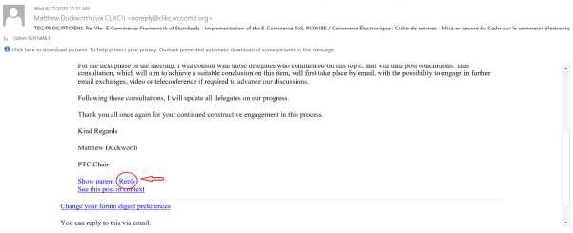
The reply option in an email
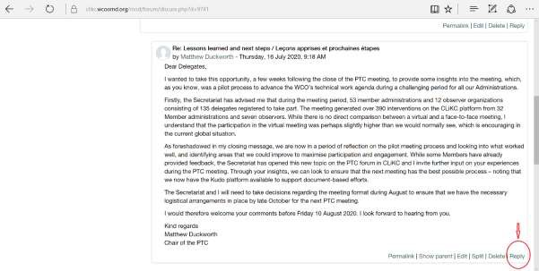
The reply option in the discussion forum itself
Comments shared by using the “Reply” option to the email notification (option 1) will be visible in the “Discussion forum” and to other delegates after a 30 minute delay, while comments shared directly in the “Discussion forum” (option 2) will be visible immediately.
The following applies for the comments being provided by delegates:
Comments can be provided in English or French. However, translation will not be available for delegates’ comments and they are therefore invited to make their internal arrangements for translations, as required;
Delegates’ comments should be as succinct as possible, with a view to making the decision-making process in a document-based environment as smooth as possible;
The delegates may view all the comments through the relevant “discussion topics” under the “Discussion Forum”.

Consensus
If there is a consensus for an item during the CLiKC! Discussion Forum, the Chairperson may then announce the item’s conclusion through the CLiKC! Forum or during the Zoom session.

Virtual Meeting Room
The CLiKC! platform does not provide virtual meeting service anymore. Delegates wishing to have bilateral meetings are advised to arrange their own chat using the services provided by Zoom, Microsoft Teams, Google Meet, Skype, WebEx or similar.

Chatroom
It provides an opportunity for live text chat with other participants of the meeting. It is possible to start different chat sessions. All participants could view all past chat sessions.
This room can be used to exchange views among the delegates out of the official Discussion Forum.

PARTICIPATION IN THE WEB-CONFERENCE (ZOOM) SESSIONS
The schedule of discussions of RSC/61 by the web-conference sessions (Zoom sessions) are indicated in the draft Timetable (Doc. NR1527).
The web-conference session will take place through the Zoom platform and represents the decision-making sessions of the meeting.
Delegates are strongly advised to refrain from making lengthy interventions on views that have already been submitted during the document-based forums of the meeting during the online meeting sessions. The Chairperson may end an intervention if this occurs.
All interventions should be succinct.

Zoom platform for web-conference sessions
The web-conference sessions of the RSC/61 meeting will take place using the Zoom platform, with simultaneous interpretation in English, French and Spanish. This is the only web conferencing tool currently being used by the WCO for meetings of working bodies with simultaneous interpretation.
Detailed information about the Zoom platform and how to access and utilize it is provided in the online meeting user guide in Annex V.
The Secretariat encourages delegates to familiarize themselves with the functionalities of Zoom before the start of the meeting and to test their connection using the link given in the Zoom user guide.
Participants should ensure that the contact details, particularly the email address used to register in the meeting and also the email associated with CLiKC! account, are correct, working and accessible. It is advisable that delegates use the same email address for registering to the Meeting and for the CLiKC! account. This is important to be able to receive the invitation to participate in the Zoom online meeting.

Opening a Zoom session
An invitation to participate in a Zoom online meeting will be sent by the Secretariat to all Members and Observers. This invitation will contain a link to enable the participants to connect to the online meeting sessions. (See paragraph above on email addresses.)
Delegates are advised not to share this link: only participants invited by the Secretariat will be authorized to take part in the online meeting. However, if needed, authorized delegates may of course share facilities and use a single sign-on if physically together at one computer.
For best results, please install the latest version of the Zoom app. If you already have the Zoom app but not the latest version it will prompt you to update it, please do so for best experience. If you try to connect to a Zoom session on a secured network, please be aware essential communication ports could be blocked by your firewall. Equally, if you try to connect through a VPN, this could block the essential communication ports that allow you to connect to the Zoom session. To avoid this, please close the app/software that you use to connect through a VPN to your administration’s domain and/or workstation. If this is not possible, the only solution would be to use a private computer or to ask your IT department to open the restricted ports on your secured network to allow you to connect to Zoom. Make sure you open the link directly on your device, rather than from within your remote domain/workstation area.
When opening a Zoom session, delegates will be asked to provide their on-screen name. This must be in the format: “Country name – Delegate Name”. This facilitates the meeting and the correct reporting of comments.

Participating in a Zoom session
As noted in the technical documents, the use of headphones is strongly recommended to ensure the smooth running of the meeting.
There are detailed instructions in the Zoom user guide on how to ask for the floor. Please read this guide carefully!

Reporting
As indicated in the Timetable, the Meeting of the RSC/61 will be closed on 25 November, after the Report reading in a Zoom session.
For blended RSC meetings, the Zoom session will only be used for reading the bilingual Annexes that have been changed during the meeting to ensure all decisions have been reflected. This special measure reflects the time limitations of live sessions.
Please note that where the Chair does not formally announce alterations to an Annex of an Agenda item in the conclusion, then the Annex will not be read during the live reading of the bilingual Annexes. The discussion on the item will be reflected as per normal practice in the narrative report. For the publication of the full report online, the unchanged Annexes will be reproduced for reference.
On Tuesday 6th December 2022, the Secretariat will send by email the “a” version of the narrative part of the Report to the Chairperson and delegates for comments (comments should be sent not later than Friday 9th December 2022).
The ‘a version’ of the narrative part of the Report and the comments received will be published on CLiKC!.
The Secretariat will include all comments received from the Chairperson and will send by email the “b” version of the draft full report by Thursday 15th December 2022.
Any comments or objections on the changes can be made up until and including Monday 19th December 2022. Please note that this period is for comment on the changes made and reflected in the “b” version only. It is not for comments on unchanged text. If no comments are received, then the report is deemed approved and a “clean” version “c”, being the final report, will be published on WCO Members’ website by Wednesday 21st December 2022.
If, however, a comment or objection is received regarding the changes incorporated into “b” version, then the Chairperson will re-convene the RSC session preceding the next HSC meeting and the report will not be finally approved until then.

*
* *

Times indicated in this Guidelines are Brussels time (Central European Time / UTC+1)
The detailed User Manual for CLiKC! is available at the following link: https://clikc.wcoomd.org/course/view.php?id=738#section-0.

